**Assignment - Data Connection | Aggregate | Joins | Unions**

**Question for data connection**

1. Connect tableau with any sample Excel ﬁle.

Ans.

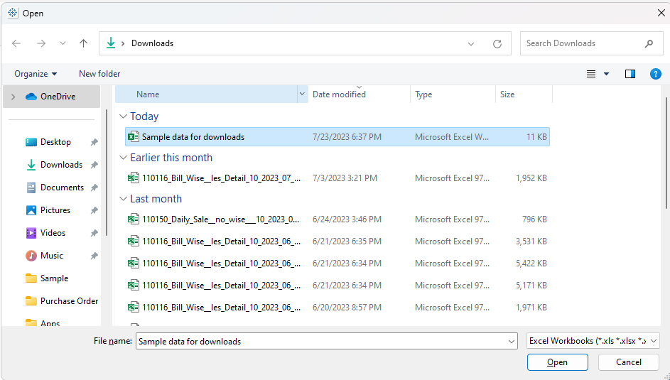

**Question for relationship and joins**

1. Create two sample sheets (tables) with a common column in excel workbook. Connect the data using relationships.

Ans.

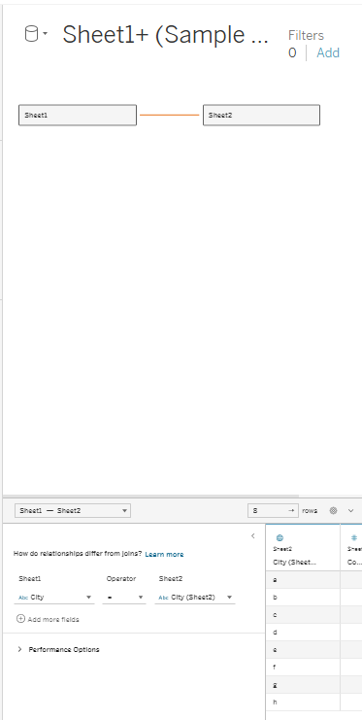

1. With the same above table data get the data connected via inner join.

Step1:

Complete the data connection step

Step2:

Now, drag the “sheet1” , ie. first table in the work space

Step3:

Before bringing the second table or the “sheet2”, double click on the “sheet 1” button (logical

table)

Step4:

After the double click, you cans see the editing space and now, drag the second sheet “sheet2”

in the work space

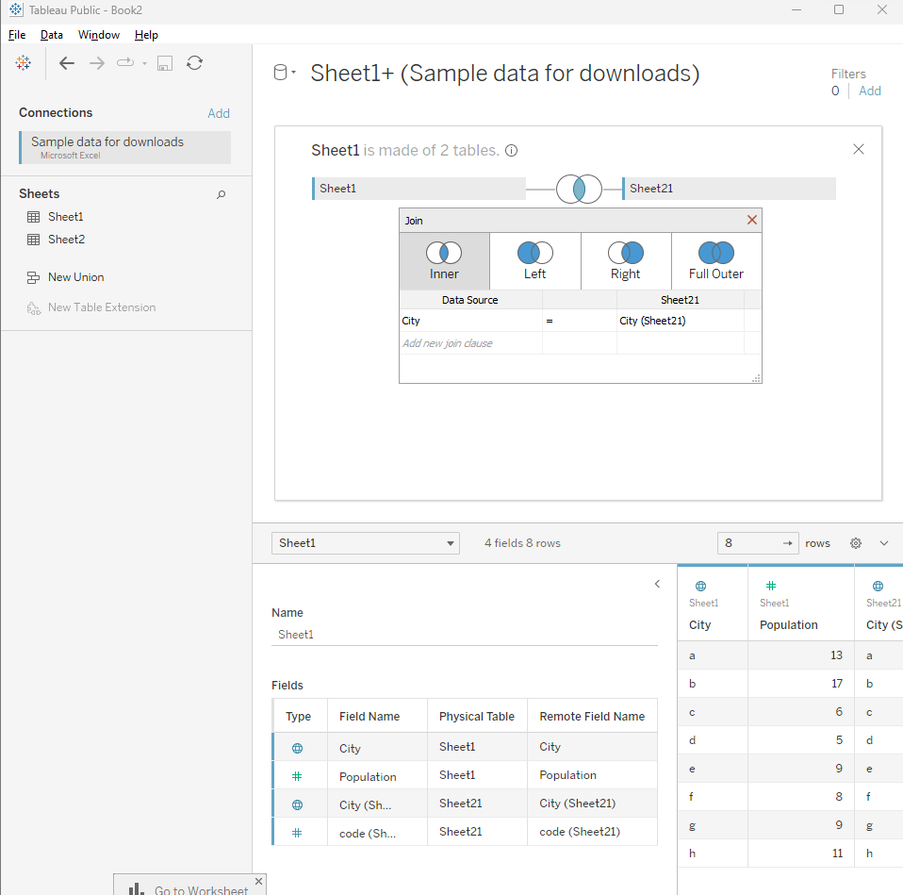

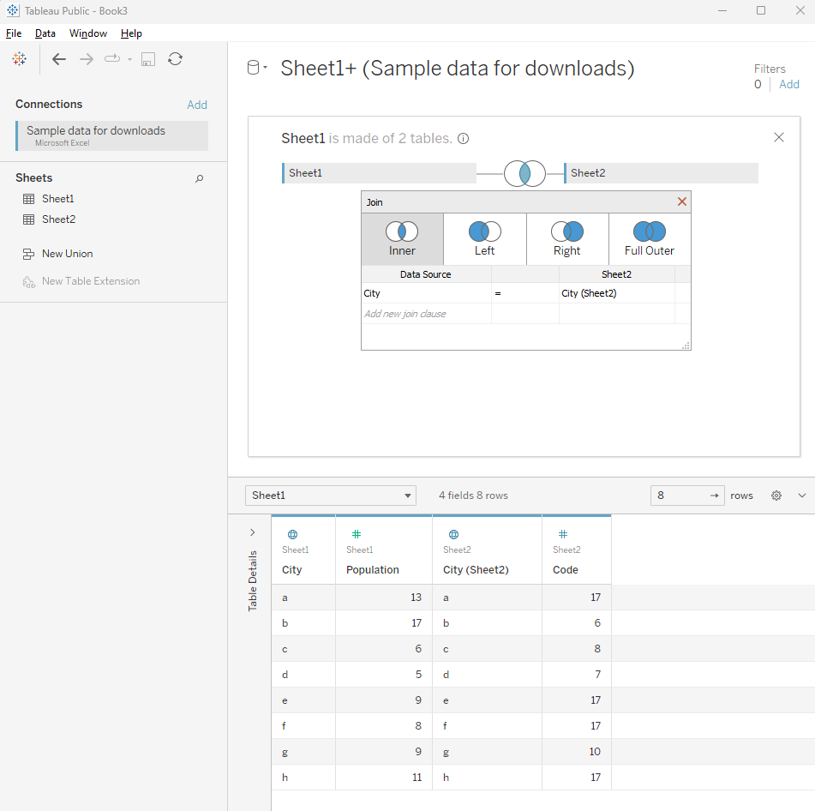

1